**PROJECT WORK**

**Phase 5**

**Traffic Management System**

**Name : Boggula Venkata Tejesh**

**Reg. no : 723921243007**

Traffic Management Objectives:

1. *Safety:* Ensure the safety of pedestrians and drivers by minimizing accidents and hazards on the road.

2. *Efficiency:* Optimize traffic flow to reduce congestion and travel time for all road users.

3. *Environmental Impact:* Minimize the environmental impact of traffic by reducing emissions and energy consumption.

4. *Data Collection:* Gather real-time traffic data for analysis and decision-making.

5. *Sustainability:* Promote sustainable transportation methods such as public transit, cycling, and walking.

6. *Public Awareness:* Educate the public about traffic rules and safety measures.

7. *Emergency Response:* Enable efficient emergency response by giving priority to emergency vehicles.

IoT Sensor Setup:

Setting up IoT sensors for traffic management involves installing various sensors at strategic locations, such as intersections or along roadways. These sensors can include cameras, ultrasonic sensors, infrared sensors, and more. They collect data on vehicle and pedestrian movements, road conditions, and environmental factors. The data is transmitted to a central server for analysis and decision-making. IoT sensors are crucial for real-time traffic monitoring, incident detection, and traffic signal optimization.

Mobile App Development:

Developing a mobile app for traffic management can be highly beneficial. Such an app can provide real-time traffic information to users, offer navigation and route optimization, and allow reporting of traffic incidents or road issues. Key steps in mobile app development include:

- Defining the app's features and functionality.

- Choosing the platform (iOS, Android, or both).

- Designing the user interface (UI) and user experience (UX).

- Developing the app using programming languages like Java (for Android) or Swift (for iOS).

- Integrating with data sources such as traffic sensors or mapping APIs.

- Testing, debugging, and optimizing the app.

- Launching the app on app stores and continuously updating it based on user feedback and changing traffic conditions.

Raspberry Pi and Code Implementation:

Raspberry Pi is a cost-effective single-board computer that can be used in traffic management solutions. Here's a simplified example of using a Raspberry Pi for a traffic monitoring system with Python:

1. Set up a Raspberry Pi with a camera module.

2. Install necessary libraries, e.g., OpenCV, to process the camera feed.

3. Write Python code to capture and analyze video data for detecting traffic flow or incidents.

4. Send the processed data to a central server or database for storage and analysis.

5. Implement decision-making algorithms to control traffic signals based on the data.

This is just a high-level overview. In a real-world scenario, you would need to consider issues like data security, power supply, and scalability. Traffic management systems often involve more complex setups and additional sensors for comprehensive data collection and analysis.

Certainly! Here's a simplified Python code snippet to simulate a basic traffic light control system using a Raspberry Pi and GPIO (General Purpose Input/Output) pins:

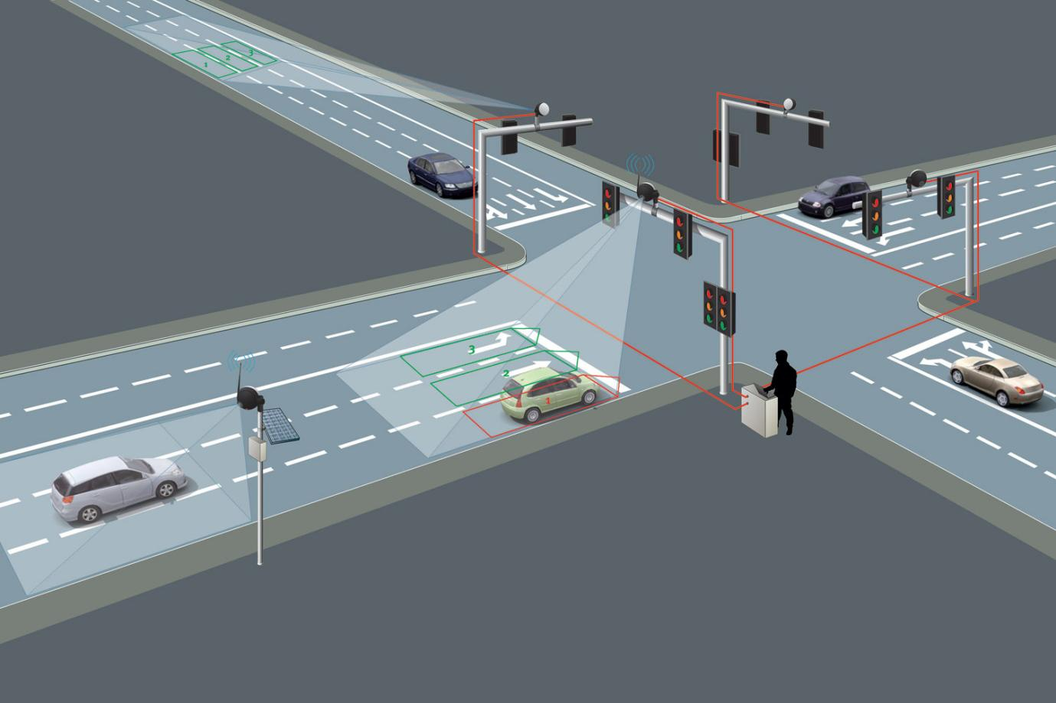

python

import RPi.GPIO as GPIO

import time

# Set up the GPIO pins for the traffic lights

red_pin = 17

yellow_pin = 18

green_pin = 27

# Set the GPIO mode to BCM

GPIO.setmode(GPIO.BCM)

# Initialize the GPIO pins

GPIO.setup(red_pin, GPIO.OUT)

GPIO.setup(yellow_pin, GPIO.OUT)

GPIO.setup(green_pin, GPIO.OUT)

def set_lights(red_on, yellow_on, green_on):

GPIO.output(red_pin, red_on)

GPIO.output(yellow_pin, yellow_on)

GPIO.output(green_pin, green_on)

try:

while True:

# Simulate traffic light sequences

set_lights(1, 0, 0) # Red

time.sleep(5)

set_lights(1, 1, 0) # Red and Yellow

time.sleep(2)

set_lights(0, 0, 1) # Green

time.sleep(5)

set_lights(0, 1, 0) # Yellow

time.sleep(2)

except KeyboardInterrupt:

GPIO.cleanup()

This code sets up the Raspberry Pi GPIO pins to control a traffic light simulation. It simulates the traffic light sequence of red, red-yellow, green, and yellow, with time intervals. You'll need to connect the actual LEDs to the specified GPIO pins.

Please ensure you have the RPi.GPIO library installed on your Raspberry Pi for this code to work. Additionally, use caution when working with hardware components like LEDs and Raspberry Pi GPIO pins.

